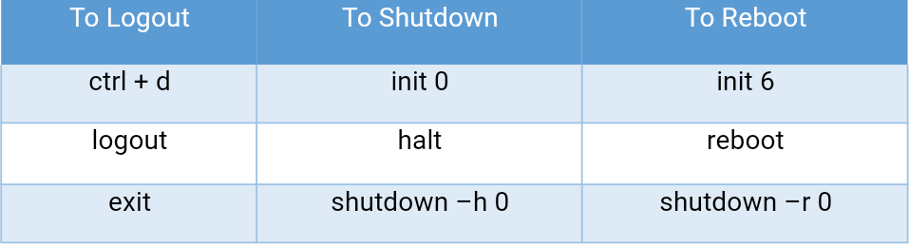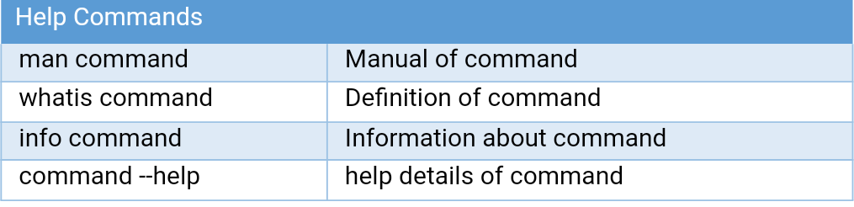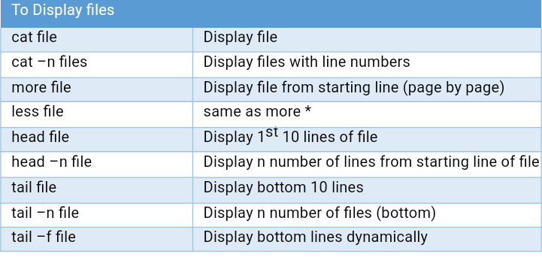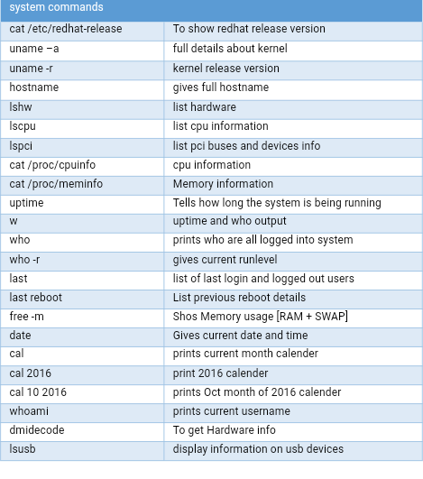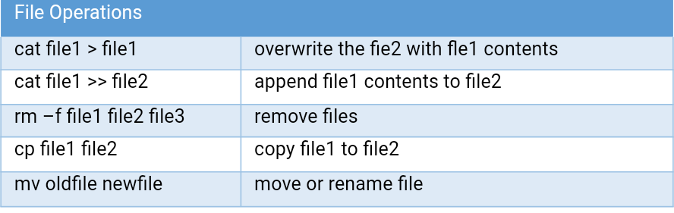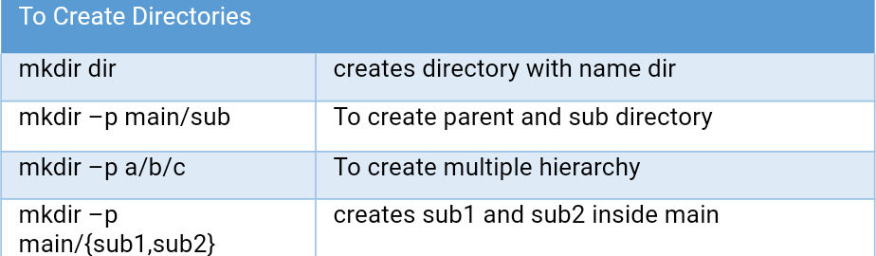

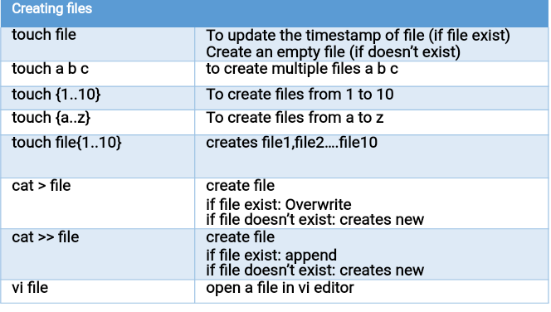

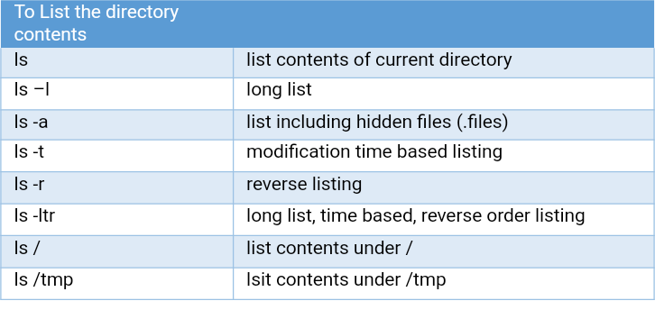 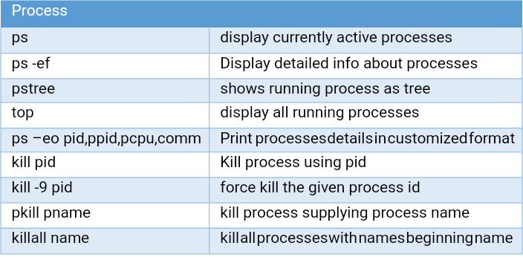

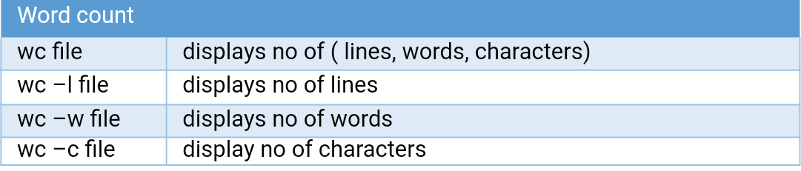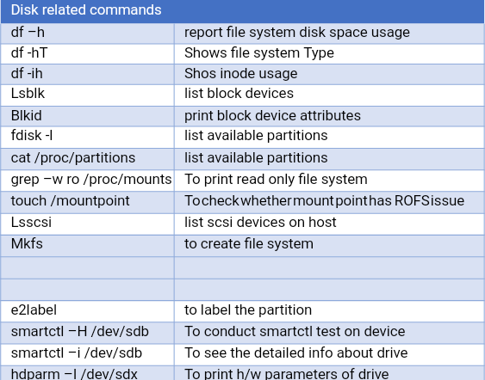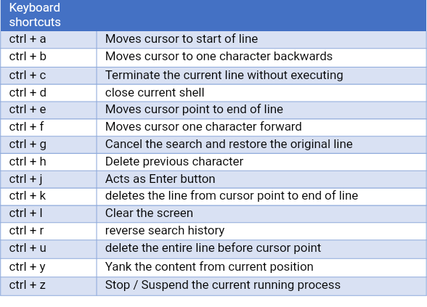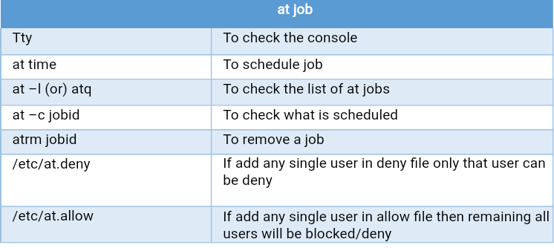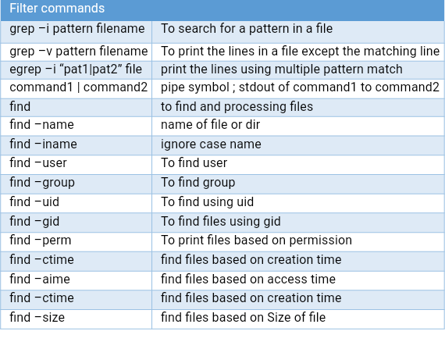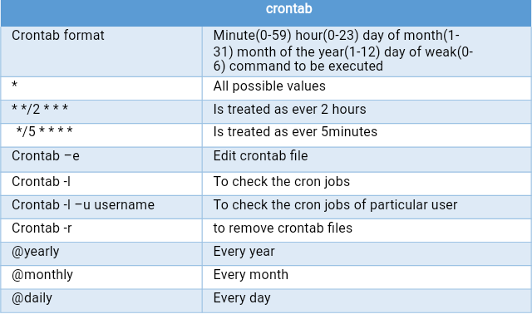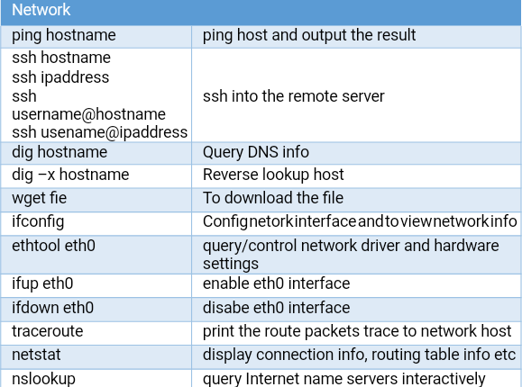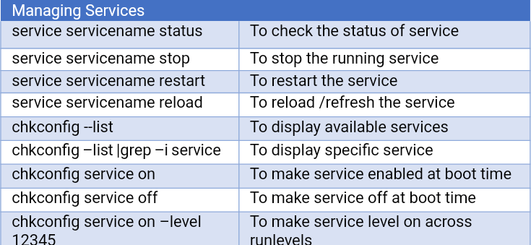

| **Group management** | |
| --- | --- |
| /etc/group | It will store all group information |
| /etc/gshadow | It will store all group password information |
| groupadd groupname | Create group name |
| groupadd -g gid groupname | Create group with user specified group id |
| groupmod –g gid groupname | To change group id |
| groupmod –n newname oldname | To change group name |
| groupdel groupname | To delete group account |
| gpasswd groupname | To set group password |
| gpasswd –r group name | To delete group password |
| gpasswd –a username groupname | To Add single user into group |
| gpasswd –m user1,user2,user3 groupname | To add multiple users into group |
| gpasswd –d username groupname | To delete user with particular group |

| **User management** | |
| --- | --- |
| /etc/passwd | It will store all user information |
| /etc/shadow | It will store all user password information |
| useradd username | Add a user |
| passwd username | Assigning password to the user |
| usermod -l newname oldname | To change user name |
| usermod –u newid username | To change user id |
| usermod -g newgid username | To change group id |
| usemod -c “hello” username | To change comment |
| usermod -d /home/newname username | To change home directory name |
| usermod –s /bin/newshell username | To change the shell |
| id username | To display uid,gid&groups for user (or) it will give group names |
| groups username | To display only groups in particular user |
| passwd –l username | To Lock user |
| passwd –u username | To unlock user |
| passwd –d username | To remove/delete passwd |
| passwd –s username | To check the user is locked or not |
| userdel username | Only delete user account |
| userdel –r username | To delete user account including all files |
| passwd –x -1 username | To set the password never expiry |
| chage –l username | To see the user password information |
| chage username | To set the password user |
| chage –f username | Force to change password for first time login |
| usermod –g group1,group2,group3 username | One user can add into multiple groups |
| id –a username | To check primary and secondary group of user |
| usermod -- yy-dd-mm username | To set expire date for user or account |
| usermod –g gid username | To change secondary group name |

| **YUM(YELLOWDOG UPDATER MODIFIED)** | |
| --- | --- |
| /etc/yum.reps.d/ | To create local repository |
| yum clean all | Like clean or refresh the package |
| yum list available | To check our repository is functioning or not |
| yum list | To list all available packages |
| yum install packagename | To install package |
| Yum install packagename -y | To install package without prompt y/n |
| yum install packagename packagename | To install multiple packages at a time |
| yum remove packagename | To remove (OR) uninstall the package |
| yum remove packagename -y | To remove package without prompt y/n |
| yum list installed | To see all installed packages |
| yum list install packagename | To see particular package is installed or not |
| yum info packagename | To information of installed package |
| yum update packagename | To update the package |
| yum repolist | To see available repo lists |
| yum deplist packagename | It will display how many dependencies there in package |
| yum repolist all | We can see repo is enabled or disabled |
| yum install packagename –skip –broken | To install package no dependency (incase error will occure i.e nodepenedency package) |
| yum install --downloadonly packagename | It will download package only not install |
| yum info packagename | To display package information |
| yum –downgrade packagename | To downgrade the package |

| **RPM(REDHAT PACKAGE MANAGER)** | |
| --- | --- |
| rpm –qa packagename | To check all installed packages |
| rpm –ivh packagename (v=verbose,h=hash) | To install the rpm package |
| rpm –ivh packagename -- force | To install the package forcelly |
| rpm –ivh packagename --nodeps | To install the package without dependecy |
| rpm packagename  rpm –qa |grep –i packagename | To check the package is installed (OR) not |
| rpm –qi packagename | to see the information about installed package |
| rpm –qc packagename | to see the configuration file about installed package |
| rpm –qd packagename | to see the directory with which package is associated |
|  |  |
| rpm –u packagename | Upgrade the package if package exit upgrade the package If not exit install the package |
|  |  |
| rpm –F packagename | update the package if package exit update the package If not exit skip the package |
| rpm –V packagename | Verify the package if any file are missing |
|  |  |
| rpm –e packagename | To remove/erase the package |

| **RAID** | |
| --- | --- |
| mdadm | Is a command/utility to manage the software raids |
| /proc/mdstat | To see the software raid |
| lspci | To see the hardware raid |
| mdadm --create --verbose --level=0 --raid-disk=2 mdo /dev/sdb1 /dev/sdb2 | To create raid0 with two partitions |
| mdadm --create --verbose --level=1 --raid-disk=2 md0 /dev/sdb1 /dev/sdb2 | To create raid1 with two partitions |
| mdadm --create --verbose --level=5 --raid-disk=3 md0 /dev/sdb1 /dev/sdb2 /dev/sdb3 | To create raid5 with three partitions |
| mdadm --create --verbose --level=10 --raid-disk=4 mdo /dev/sdb{4,5,6,7) | To create raid10 with four partitions |
| llsblk | To verify software raids |
| mdadm --details /dev/md0 | To see detailed information about particular raid |
| mdadm --fail /dev/md0 /dev/sdb1 | To remove the drive first faild the particular the drive |
| mdadm --remove mdadm dev/md0 /dev/sdb1 | To remove the drive |
| mdadm --stop /dev/md0 | To stop the drive |
| mdadm --add /dev/md0 /dev/sdb1 | Add the device in particular raid |
| mdadm --detail --scan /dev/md0 >>/etc/mdadm.conf | Date moves into mdadm.conf file |
| Mdadm --assemble /dev/md0 | To assemble the data for without creation |